

Preamble

This section of the report will cover details of how we were welcomed in the host company, presentation, organization and brief introduction to our project.

Content

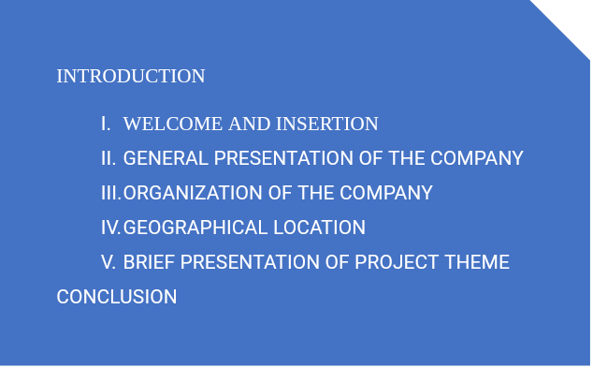

INTRODUCTION

The insertion phase in a company is a period during which we discover our working  
environment, the staff of the company and other interns. Here, we will begin by discussing our first two weeks in the company, how we were welcomed and how we began adapting to our internship environment, we will proceed by exploring the history of the company, discovering its missions, learning what its major activities are, and witnessing some of its key realizations. We will also get to understand how the company is structured administratively and functionally so that it operates effectively and accomplishes its goals. Furthermore, we will look at the hardware equipment used by the company, and the software resources used in its daily operations. We will then introduce our chosen theme for the internship period, briefly elaborate on It.

I-WELCOME AND INSERTION

We arrived at SHADERL on Tuesday 01st July 2025, at 08:00 a.m. we were received by the shaderl team who introduced us to our workspace, gave us an official welcome to the enterprise, its activities and its different rules and regulations. Also, we discussed on the enterprise’s preferred languages and frameworks, our professional supervisor encouraged us through his past working experiences in different enterprises.

The first two week we started with our internship report by configuring our MS WORD processor, reviewing key concepts like page numbering, styles, section breaks, page breaks etc. There was a talk on project ideas, we were advised to propose project ideas and we were assigned the tasks to carry out research on these ideas. The objective was that the enterprise did not want to impose some themes on us. For those who could not find a theme, the enterprise could propose an idea for them to think about.

II-GENERAL REPRESENTATION OF SHADERL

A-Background:

Shaderl is a dynamic, non-governmental tech startup founded in 2023 by **Asane Derick** with a bold vision: to bridge the gap between traditional industries and the rapidly evolving digital economy. Recognizing the urgent need for digital transformation, Shaderl is committed to providing **cutting-edge IT solutions** while empowering the next generation of innovators.

B- Mission

At Shaderl, we harness the power of **AI and cutting-edge technology** to democratize digital transformation. Our mission is to **empower individuals and businesses** with intelligent tools, accessible education, and personalized mentorship bridging the gap between today’s potential and tomorrow’s opportunities. We believe AI should **augment human potential, not replace it**. By making AI-driven solutions practical and ethical, we equip the next generation to lead, innovate, and thrive in an era where **human creativity meets machine intelligence**.

C-Vision

At Shaderl, we envision a world where **technology unites humanity**, where innovation is driven by collective purpose, not just profit. By putting **“PeopleFirst”**, we strive to build a future where:

* **One Love**→ Technology fosters **inclusion, empathy, and global collaboration**, breaking down barriers.
* **One Mind**→ AI and digital tools **amplify human potential**, creating shared knowledge and opportunity.
* **One Legacy**→ Every individual we empower leaves a lasting impact, shaping a **smarter, kinder, and more connected world**.

We don’t just adapt to the digital age; we **redefine it with humanity at the core**.

D- ACTIVITIES

The activities of SHADERL range from computer sciences, engineering, and training. We can outline the following:

➢ Conception realization, and hosting of websites.

➢ Software development and maintenance.

➢ Training in Software related fields.

➢ Conception and realization of multimedia.

➢ IT consulting and innovation.

➢ IT support.

III-ORGANISATION OF SHADERL

Shaderl is administratively organized as follows:  
a- **Executive Leadership**

**This department is responsible for:**  
✓ Setting the company's vision, mission, and strategic direction  
✓ Making high-level decisions about investments, partnerships, and growth  
✓ Representing Shaderl in key meetings with investors and government agencies  
✓ Ensuring all departments align with the company's core values and objectives  
✓ Overseeing the overall performance and sustainability of the organization

b. **Software Engineering Department**  
 **This department is responsible for:**  
✓ Designing, developing, and maintaining all of Shaderl's software products  
✓ Implementing AI and machine learning solutions for company offerings  
✓ Ensuring software security, scalability, and optimal performance  
✓ Collaborating with other departments to understand technical requirements  
✓ Staying updated with emerging technologies and industry best practices

c. **Human Resource Department**

**This department is responsible for:**  
✓ Recruiting and onboarding top talent that aligns with Shaderl's values  
✓ Managing employee relations, welfare, and performance evaluations  
✓ Developing training programs to enhance staff skills and capabilities  
✓ Maintaining company culture and ensuring a positive work environment  
✓ Handling compensation, benefits, and conflict resolution

d **Communication Department**

**This department is responsible for:**✓ Managing Shaderl's public image and brand reputation  
✓ Developing and executing marketing and PR strategies  
✓ Handling all internal and external communications  
✓ Managing social media platforms and digital content  
✓ Organizing corporate events and press engagements

e **Department of Financial Affairs**

**This department is responsible for:**✓ Managing all financial operations and accounting  
✓ Preparing budgets and financial forecasts  
✓ Handling payroll, taxes, and financial reporting  
✓ Ensuring compliance with financial regulations  
✓ Managing investments and financial partnerships

B- Functional organisation

The functional branch of shaderl is organized as follows:

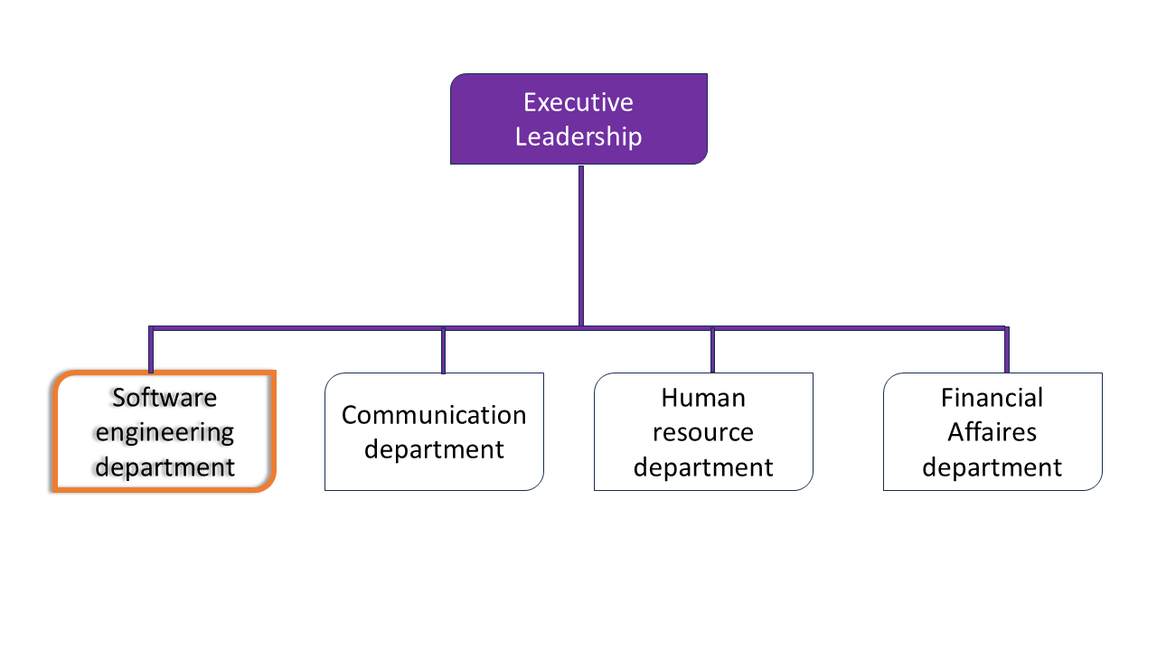

IV- GEOGRAPHICAL LOCATION

*DRAW YOUR MAP HERE.*

V- BRIEF PRESENTATION OF THE PROJECT THEME

CONCLUSION

*That’s the insertion phase above, organise it well on your document,*